Full Name: Neeraj Kumar
Project Name: Linux Capstone Project 2
Submission Date: 10-Nov-2026
Operating System Used: Amazon Linux 2023 (EC2)

GitHub Project Link:

Linux Web Server Setup — Nginx, Firewall, Package Management & Log Monitoring

Project Overview
In this capstone, you will set up a production-style Linux web server from scratch. You will install and configure Nginx, manage packages, configure the firewall, monitor logs, and write a shell script that automatically checks server health. This mirrors what a junior Linux engineer does when setting up and maintaining a web server in a real company.

Topics Covered: Nginx | Package Management (YUM/APT) | Firewall Management | Log Monitoring | rsyslog | Shell Scripting | Network Commands | SSH | systemctl | crontab | grep | tail | curl | wget

Environment: AWS EC2 t2.micro (Amazon Linux 2023) — Free Tier OR Local VirtualBox VM (CentOS/Ubuntu)

Project Architecture
Linux Web Server (EC2 or VM)
├── Nginx Web Server
│ ├── Default site (port 80)
│ └── Custom HTML page
├── Firewall (firewalld)
│ ├── Allow HTTP (80)
│ ├── Allow SSH (22)
│ └── Block everything else
├── Log Monitoring
│ ├── /var/log/nginx/access.log
│ └── /var/log/nginx/error.log
└── Shell Script
└── server_health_check.sh (auto-runs every 5 min via cron)

Setup — Launch Your Environment
Option A — AWS EC2 (Free Tier):
- Launch t2.micro Amazon Linux 2023 instance
- Security Group: allow SSH (22) from My IP | HTTP (80) from Anywhere
- Connect: ssh -i "your-key.pem" ec2-user@<public-ip>
Option B — Local VirtualBox VM:
- Start your CentOS or Ubuntu VM
- Open terminal
- Switch to root: sudo su -

Phase 1 — Package Management & Nginx Installation

Step 1: System update and package management basics
Commands:

sudo su -

# Check current packages installed
rpm -qa | wc -l # CentOS/Amazon Linux
# dpkg --list | wc -l # Ubuntu

# Update all packages
yum update -y # CentOS/Amazon Linux
# apt update && apt upgrade -y # Ubuntu

# Search for a package
yum search nginx
yum info nginx

# Install useful tools
yum install -y wget curl tree net-tools bind-utils

# Verify installation
which wget
which curl
which tree

# Check package info
rpm -qi curl
rpm -ql curl | head -10

# List recently installed packages
rpm -qa --last | head -10

Output:
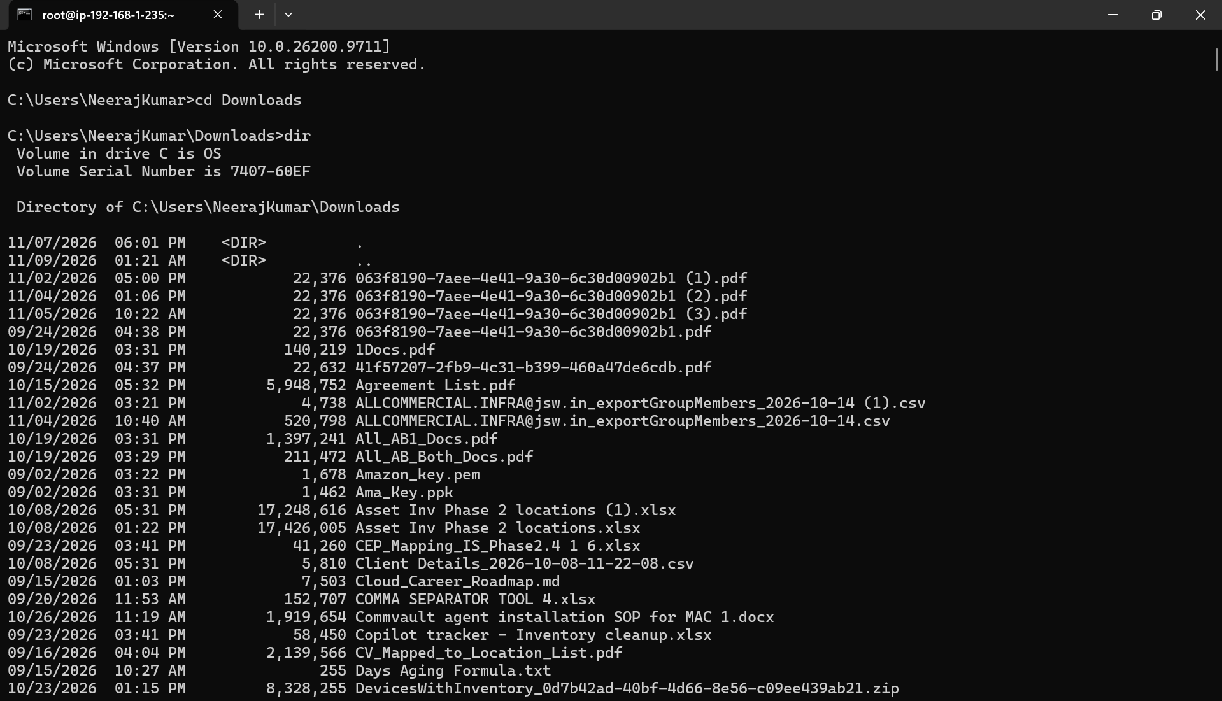
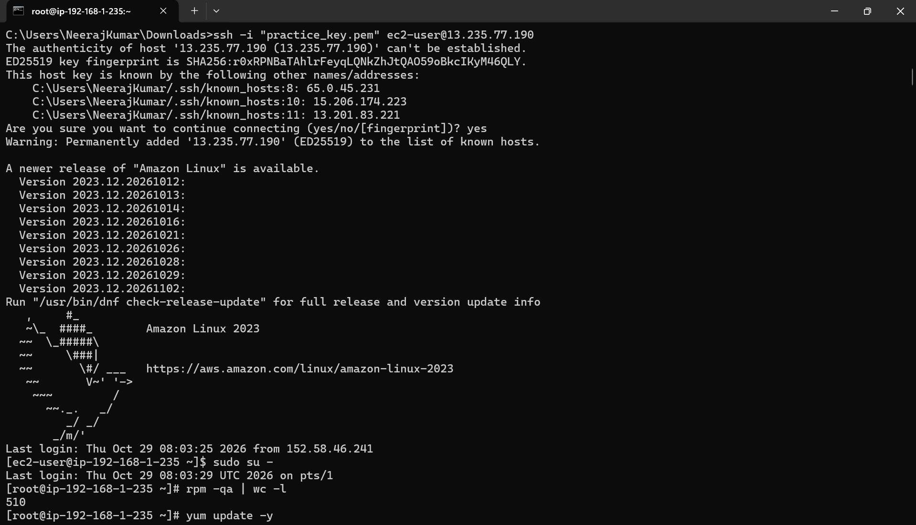
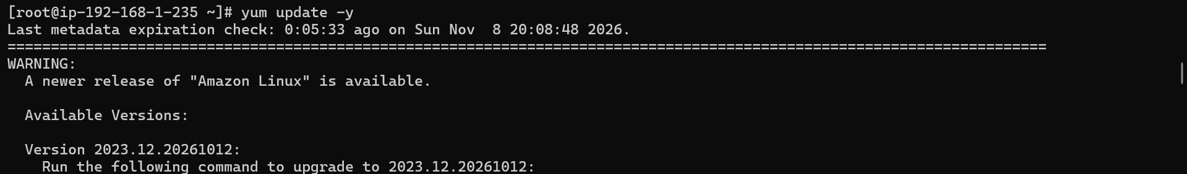
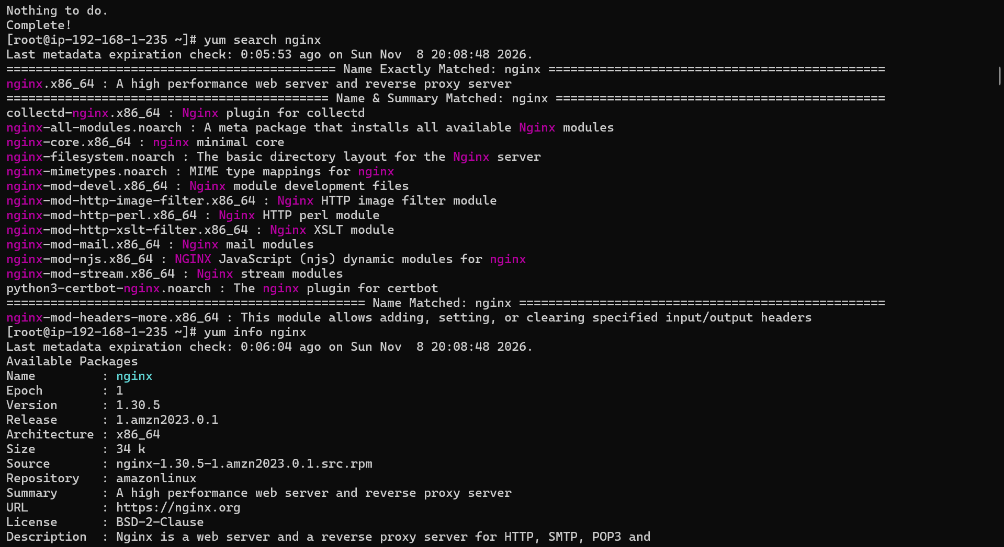
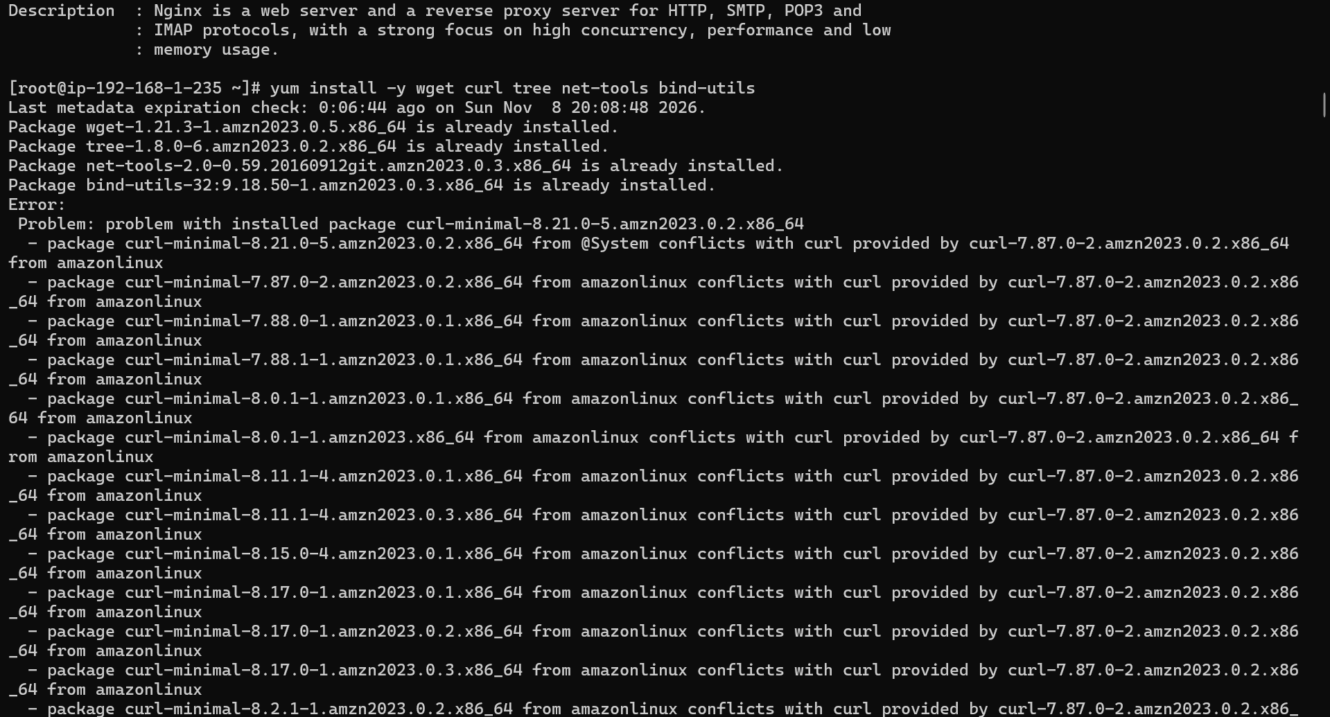
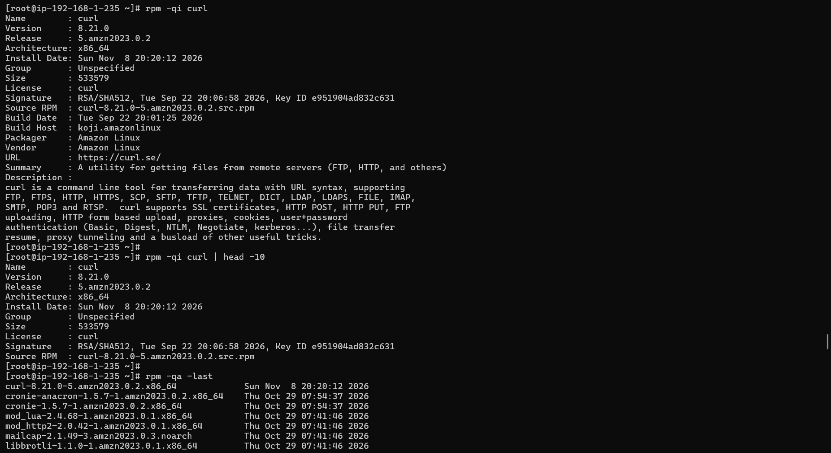
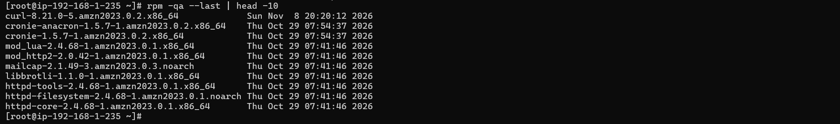

Step 2: Install and configure Nginx
Comands:

# Install Nginx
yum install -y nginx # Amazon Linux/CentOS
# apt install -y nginx # Ubuntu

# Verify installation
nginx -v
which nginx
rpm -ql nginx | head -20

# Start and enable Nginx
systemctl start nginx
systemctl enable nginx
systemctl status nginx

# Check Nginx is listening on port 80
ss -tlnp | grep :80
netstat -tlnp | grep nginx

# Test locally
curl http://localhost
curl -I http://localhost # headers only
Output:
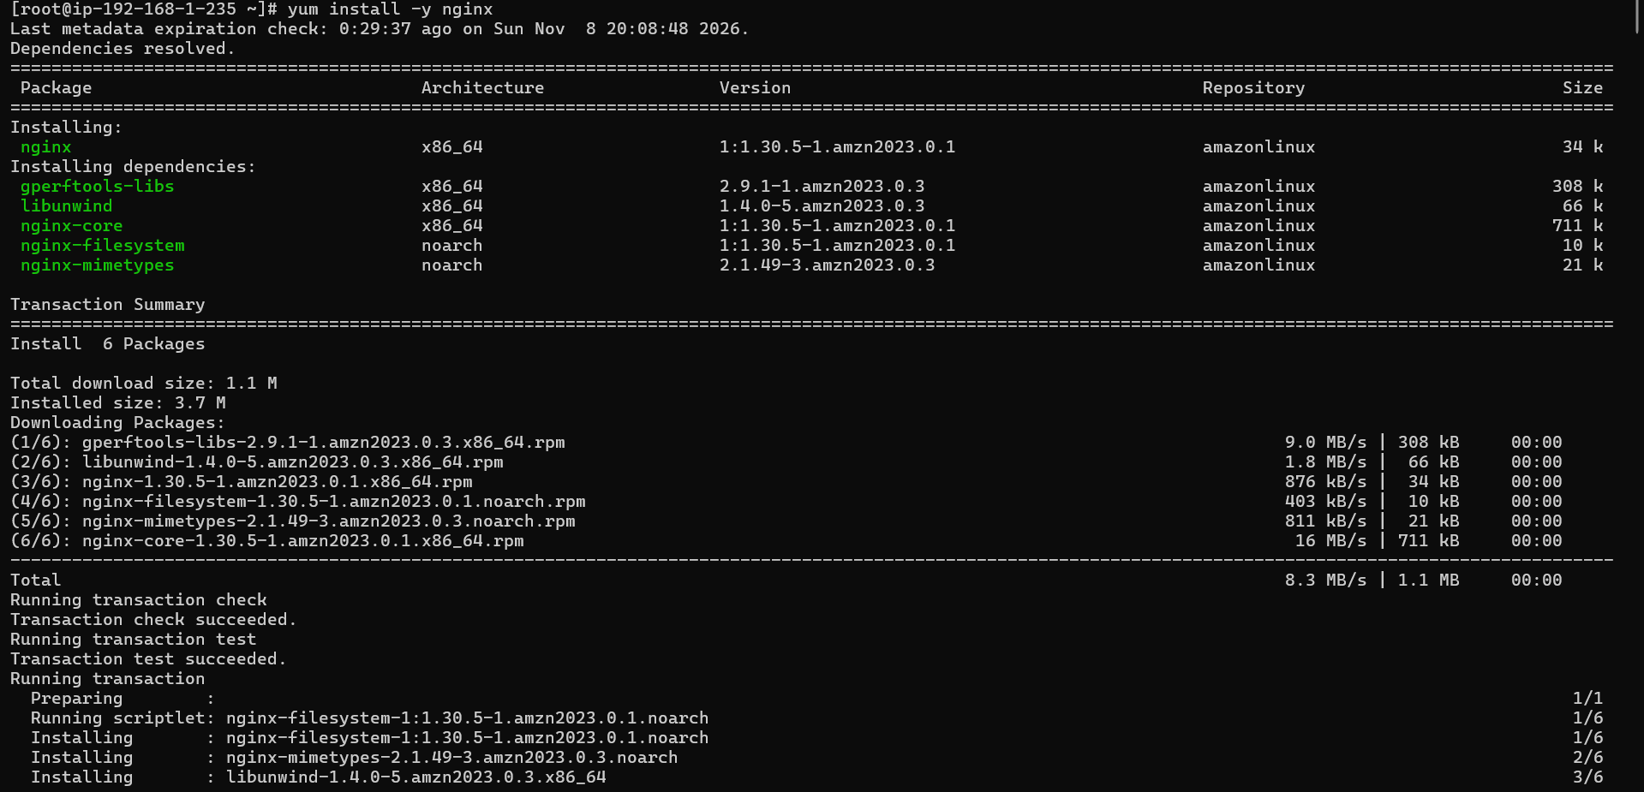
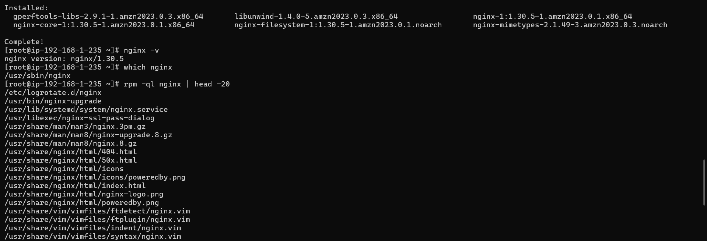
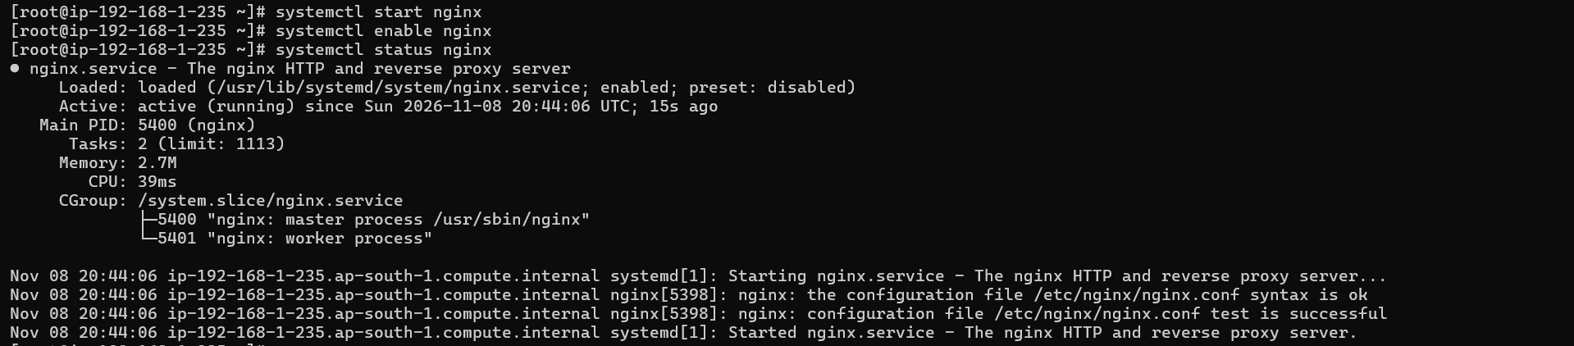
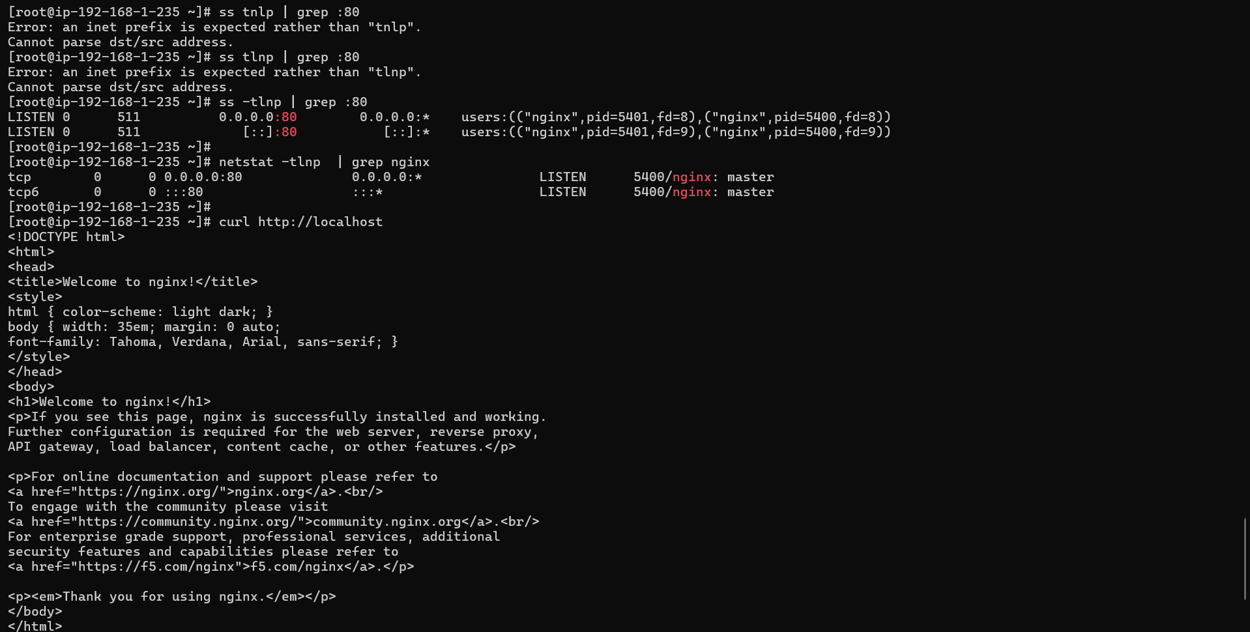
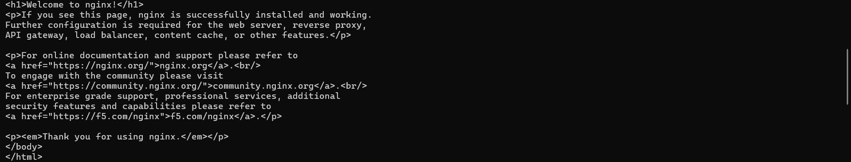
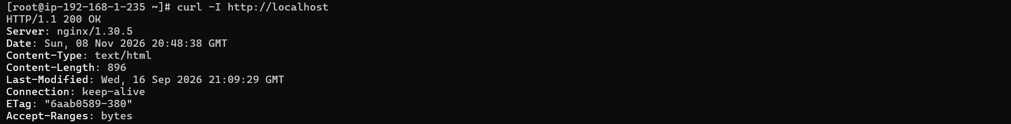

Step 3: Create a custom website
Commands:

# Backup default page
cp /usr/share/nginx/html/index.html /usr/share/nginx/html/index.html.bak

# Create custom page
cat > /usr/share/nginx/html/index.html << 'EOF'
<!DOCTYPE html>
<html>
<head>
<title>Linux Web Server — Capstone Project 2</title>
<style>
body { font-family: Arial; background: #1a1a2e; color: #eee; text-align: center; padding: 50px; }
h1 { color: #16213e; background: #e94560; padding: 20px; border-radius: 8px; }
.info { background: #16213e; padding: 20px; border-radius: 8px; margin: 20px auto; max-width: 600px; }
.green { color: #00ff88; }
</style>
</head>
<body>
<h1>Linux Web Server</h1>
<div class="info">
<p><span class="green">Status:</span> Online and Running</p>
<p><span class="green">Project:</span> Linux Capstone Project 2</p>
<p><span class="green">Student:</span> [YourName]</p>
<p><span class="green">Server:</span> Nginx on Amazon Linux 2023</p>
<p><span class="green">Purpose:</span> Junior Linux Engineer Capstone</p>
</div>
</body>
</html>
EOF

# Create a second page
cat > /usr/share/nginx/html/about.html << 'EOF'
<!DOCTYPE html>
<html>
<body style="font-family:Arial; text-align:center; padding:50px;">
<h1>About This Server</h1>
<p>This web server was configured as part of the Linux Capstone Project.</p>
<p>Technologies used: Nginx | Linux | Firewall | Shell Scripting</p>
<a href="/">Back to Home</a>
</body>
</html>
EOF

# Reload Nginx to apply changes
systemctl reload nginx

# Test in browser or with curl
curl http://localhost

If using EC2, visit http://<public-ip> in your browser — your custom page should load.

Output:
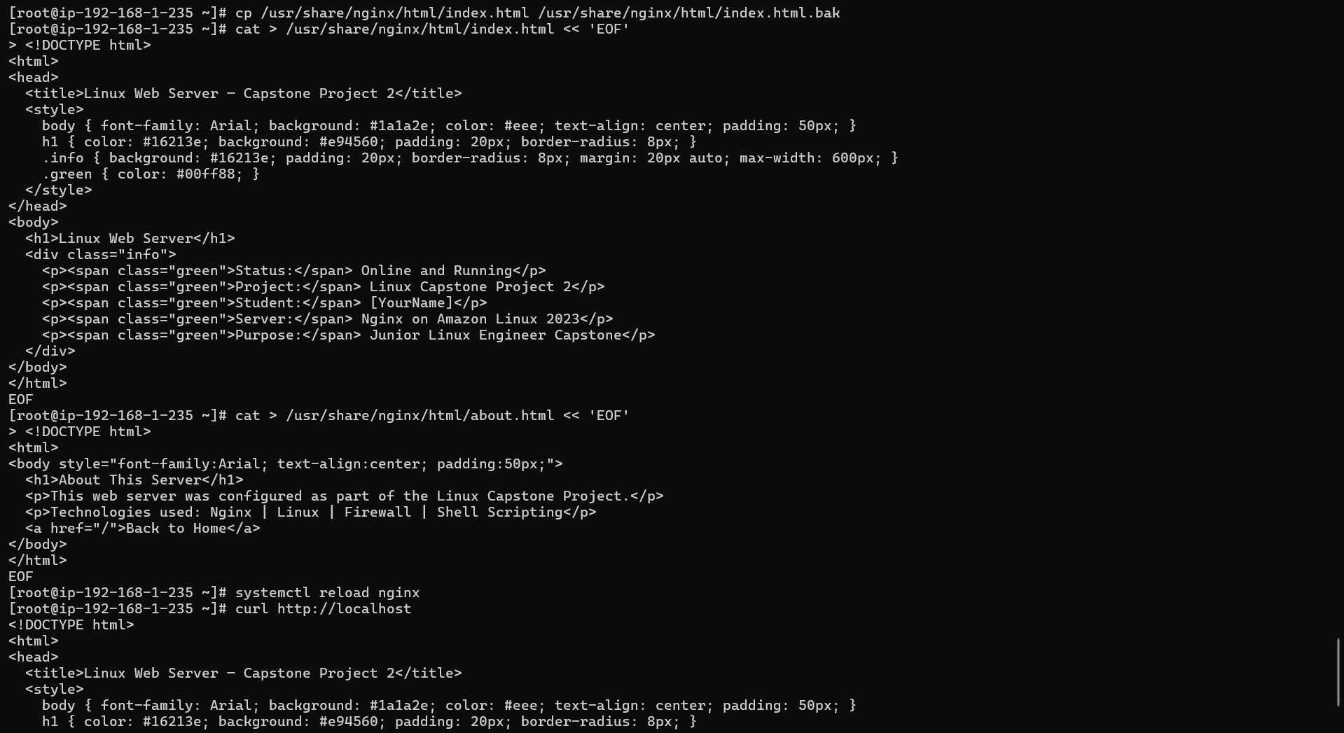
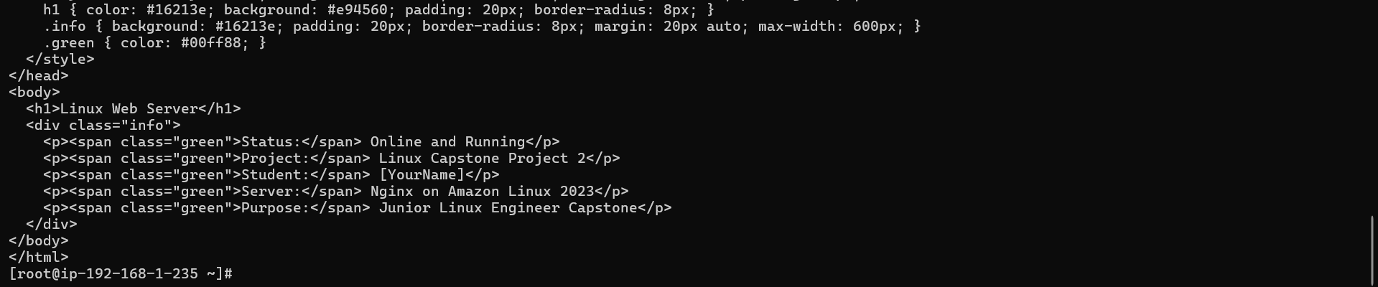

Step 4: Explore Nginx configuration
Commands
# View main Nginx config
cat /etc/nginx/nginx.conf

# View configuration directory
ls -la /etc/nginx/

# Check Nginx config syntax
nginx -t

# View default server block
cat /etc/nginx/conf.d/default.conf 2>/dev/null || cat /etc/nginx/sites-enabled/default 2>/dev/null

# View Nginx logs location
grep "access_log\|error_log" /etc/nginx/nginx.conf

Output:
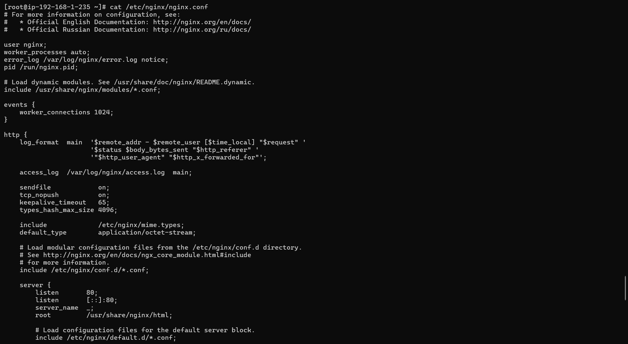
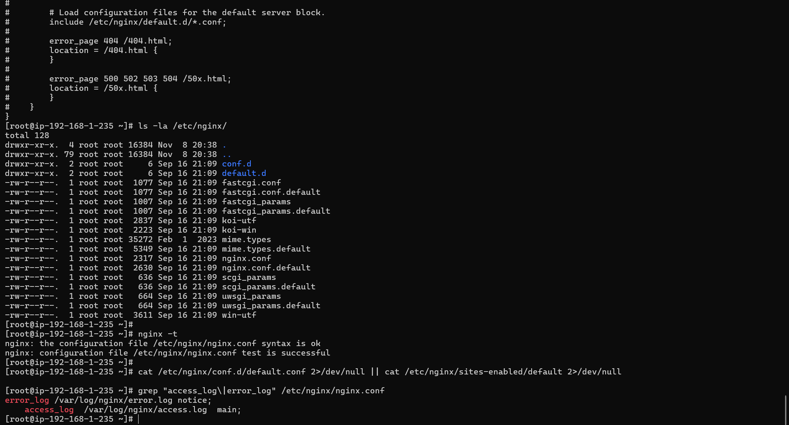

Phase 2 — Firewall Configuration
Step 5: Configure firewall with firewalld

Commands:
# Install firewalld if not present
yum install -y firewalld

# Start and enable firewalld
systemctl start firewalld
systemctl enable firewalld
systemctl status firewalld

# Check current firewall rules
firewall-cmd --list-all

# Check default zone
firewall-cmd --get-default-zone

# Allow HTTP (port 80)
firewall-cmd --permanent --add-service=http
firewall-cmd --permanent --add-service=ssh

# Allow a custom port (8080 for testing)
firewall-cmd --permanent --add-port=8080/tcp

# Reload firewall to apply permanent rules
firewall-cmd --reload

# Verify rules applied
firewall-cmd --list-all

# Remove the test port
firewall-cmd --permanent --remove-port=8080/tcp
firewall-cmd --reload
firewall-cmd --list-all

Output:
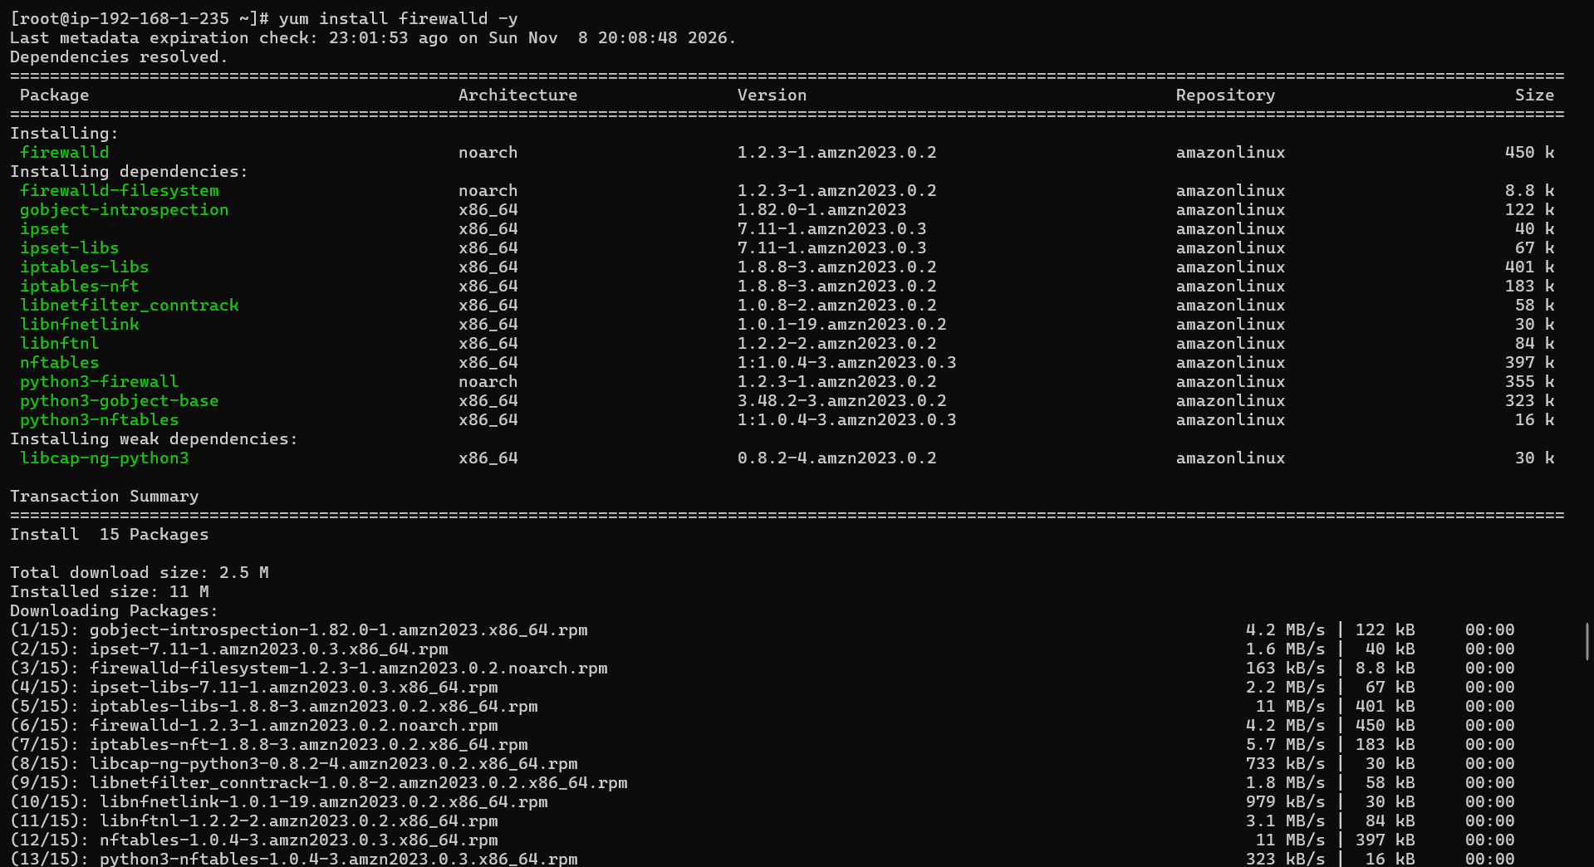
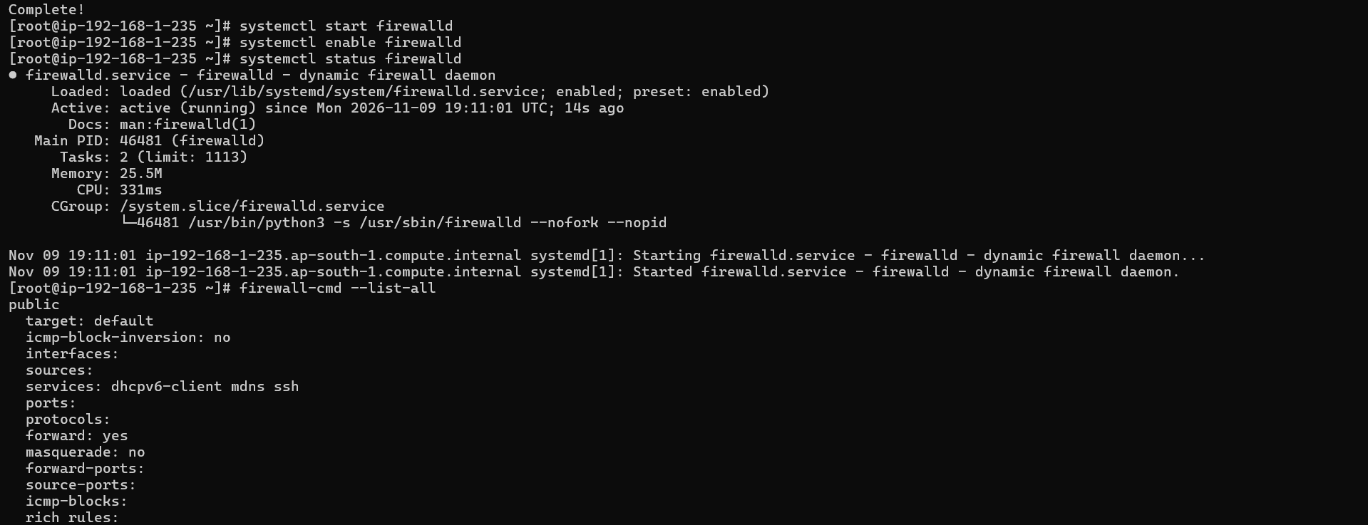
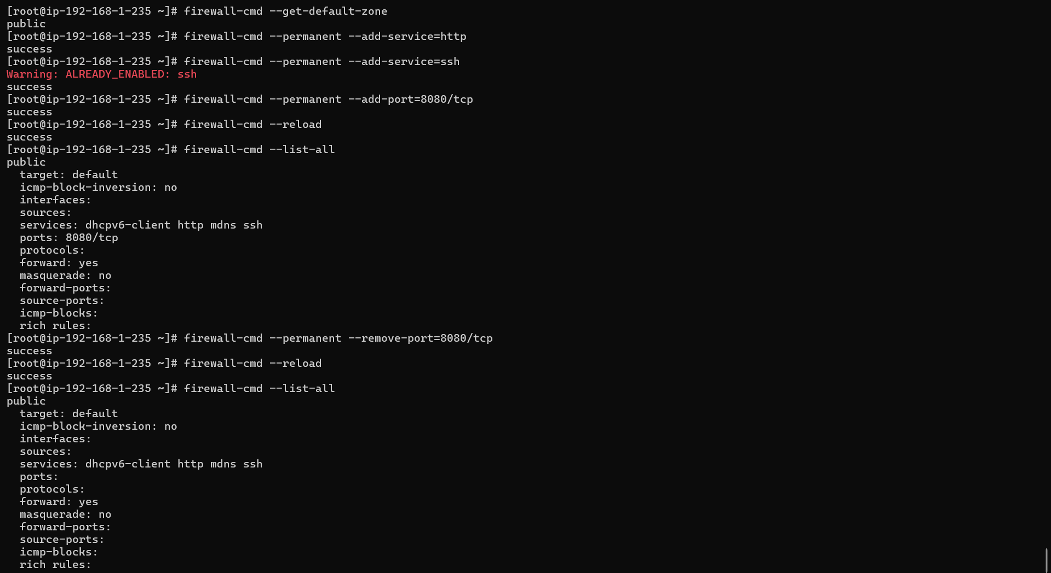

Step 6: Test firewall blocking
Commnads:

# Try to access a blocked port from the server itself
curl http://localhost:8080 # should fail/timeout after removal

# Check what ports are open
ss -tlnp
firewall-cmd --list-ports
firewall-cmd --list-services

# Block a specific IP (example — use a test IP)
firewall-cmd --permanent --add-rich-rule='rule family="ipv4" source address="192.168.100.100" reject'
firewall-cmd --reload
firewall-cmd --list-rich-rules

# Remove the IP block
firewall-cmd --permanent --remove-rich-rule='rule family="ipv4" source address="192.168.100.100" reject'
firewall-cmd –reload
Output:
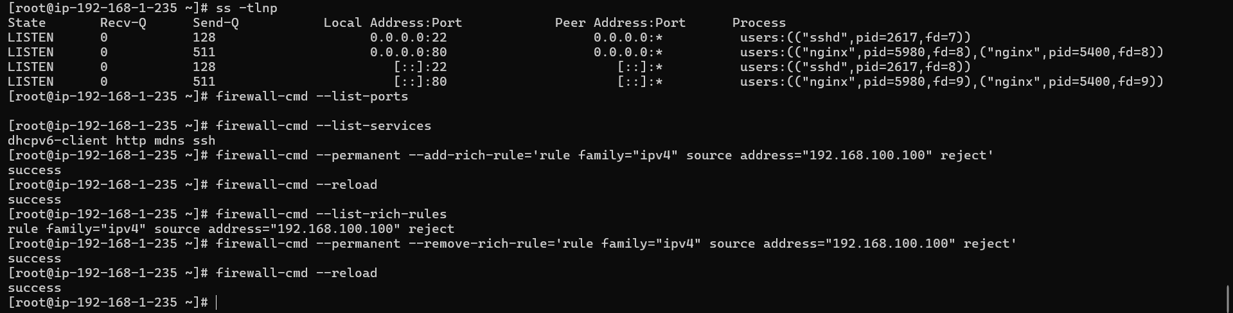

Phase 3 — Log Monitoring & Network Commands
Step 7: Generate and monitor Nginx logs
Commands:

# Generate web traffic to create log entries
curl http://localhost/
curl http://localhost/about.html
curl http://localhost/nonexistent.html # generates 404
curl http://localhost/
curl -A "TestBrowser/1.0" http://localhost/

# View access logs
tail -20 /var/log/nginx/access.log

# View error logs
tail -20 /var/log/nginx/error.log

# Real-time log monitoring (run then make requests in another terminal)
tail -f /var/log/nginx/access.log &

# Generate more traffic
for i in {1..5}; do curl -s http://localhost/ > /dev/null; done

# Stop the tail
kill %1

# Analyze logs with grep and awk
grep "404" /var/log/nginx/access.log
grep "200" /var/log/nginx/access.log | wc -l
awk '{print $1}' /var/log/nginx/access.log | sort | uniq -c | sort -rn
awk '{print $9}' /var/log/nginx/access.log | sort | uniq -c

Output:
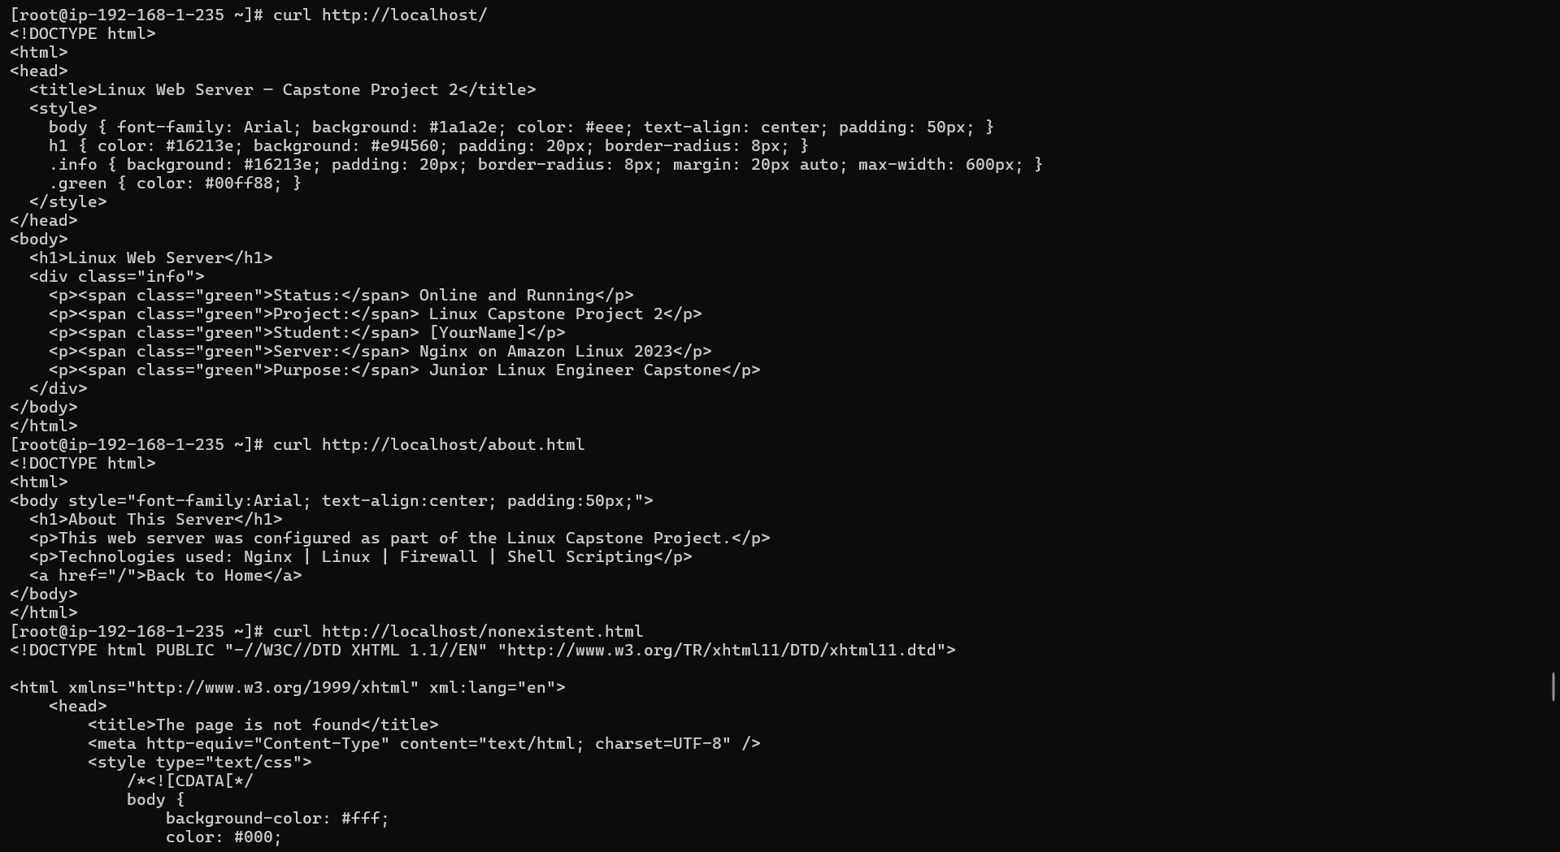
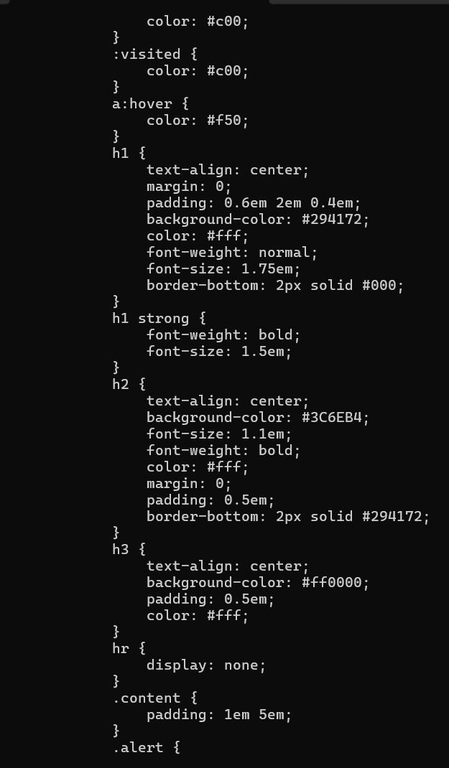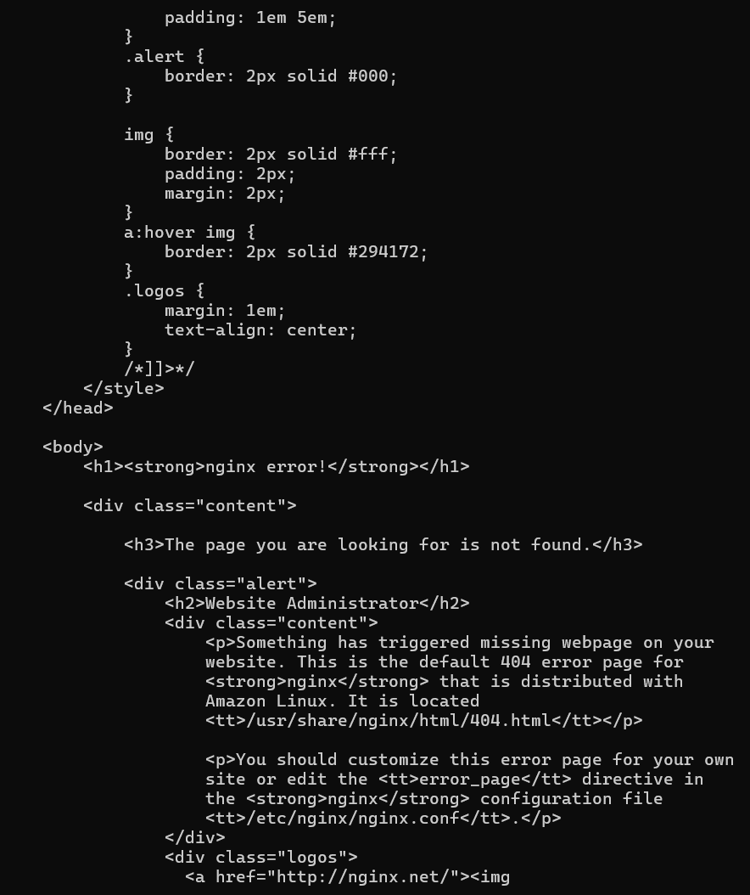
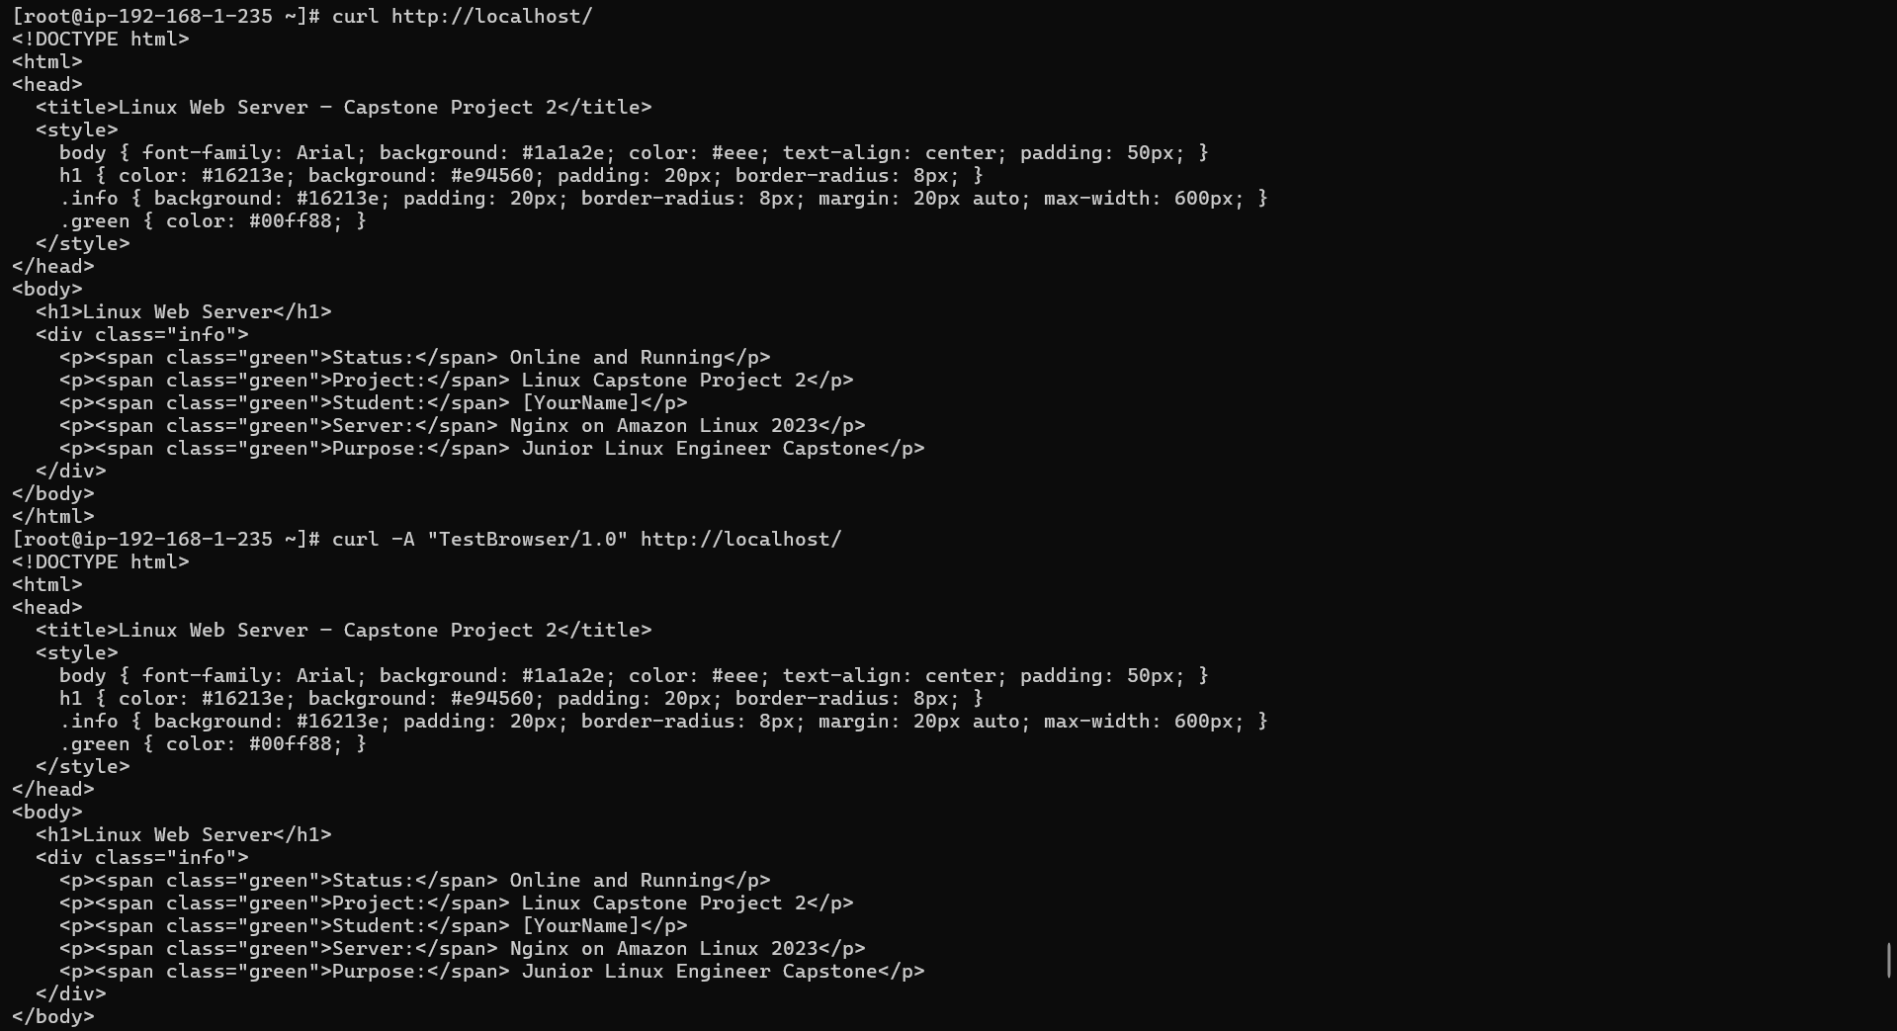
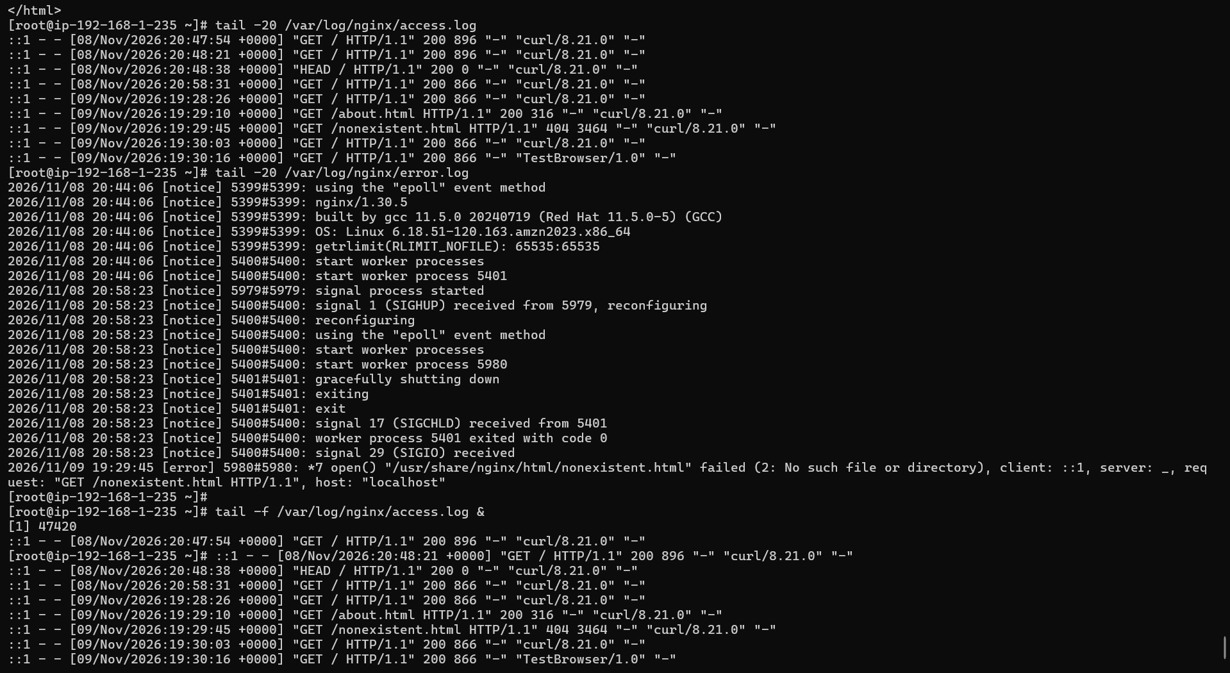
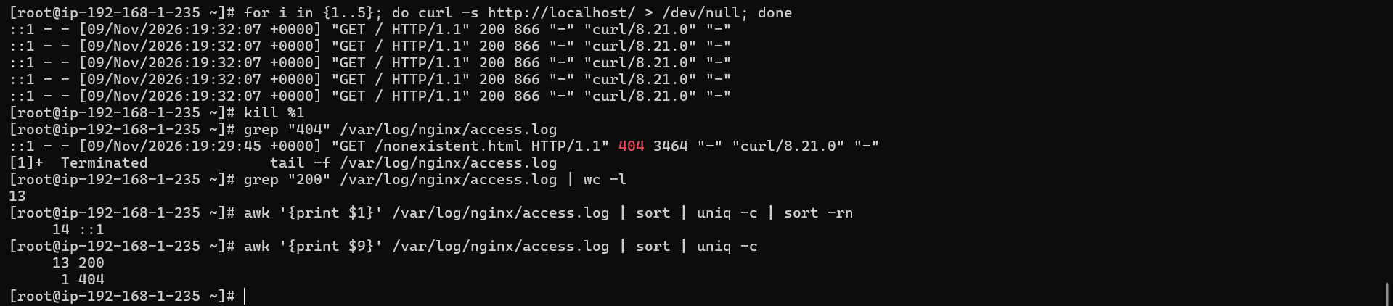
Step 8: System log monitoring
Commands:

# View system logs
tail -50 /var/log/messages # CentOS/Amazon Linux
# tail -50 /var/log/syslog # Ubuntu

# View authentication logs
tail -20 /var/log/secure # CentOS/Amazon Linux
# tail -20 /var/log/auth.log # Ubuntu

# Filter for specific events
grep "nginx" /var/log/messages
grep "Failed" /var/log/secure 2>/dev/null || grep "Failed" /var/log/auth.log 2>/dev/null

# Monitor logs live
journalctl -u nginx -f &
sleep 3
curl http://localhost
kill %1

# View journal for specific service
journalctl -u nginx --since "1 hour ago"
journalctl -u firewalld --since "today"
Output:
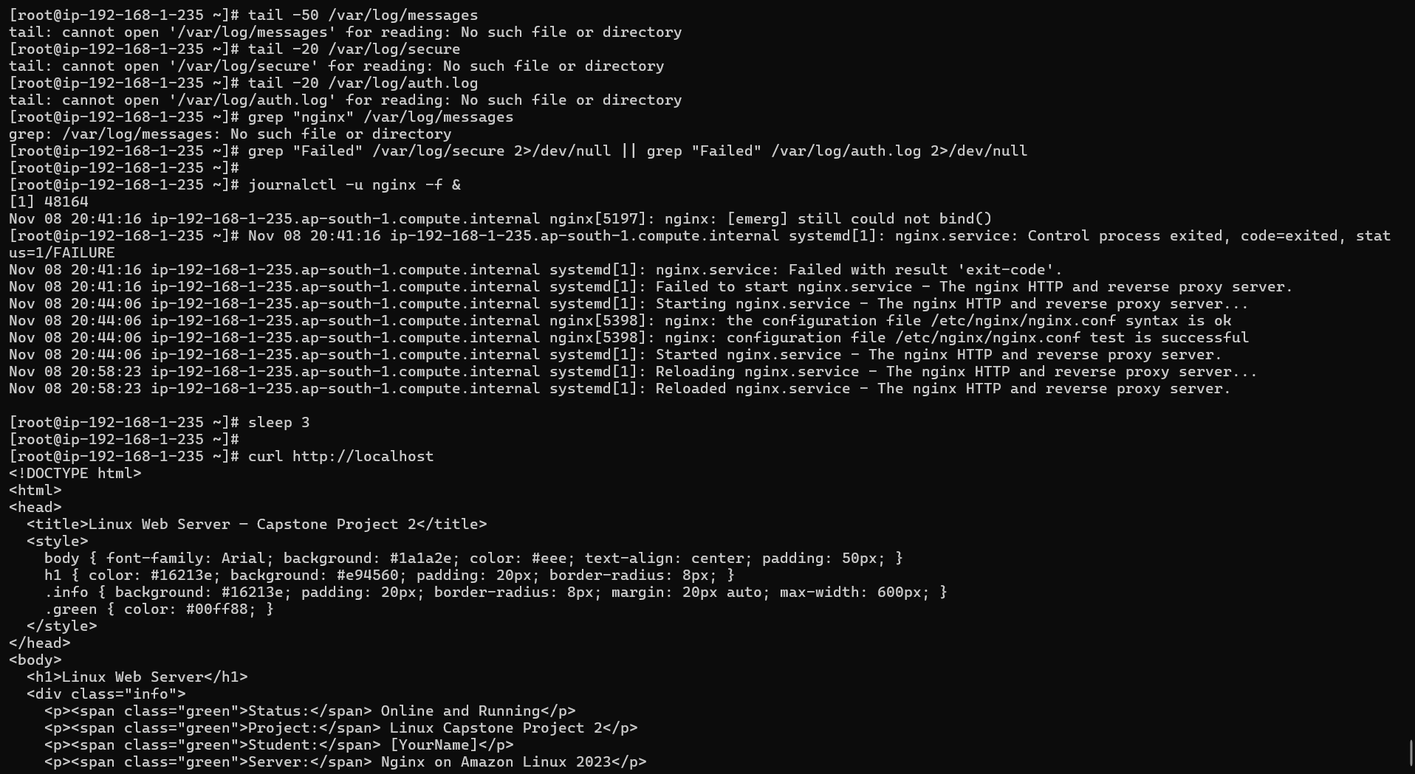
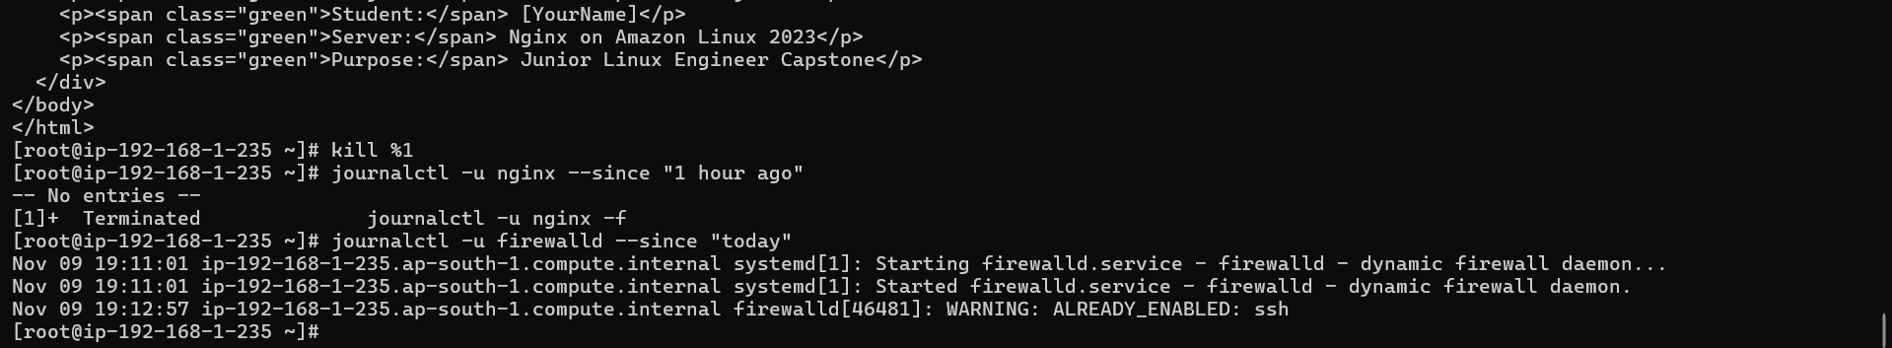

Step 9: Network commands
Commands:
# Check network interfaces
ip addr show
ip link show
ifconfig 2>/dev/null || ip addr

# Check routing table
ip route show
route -n 2>/dev/null || ip route

# Test connectivity
ping -c 4 google.com
ping -c 4 8.8.8.8

# DNS lookup
nslookup google.com
dig google.com
dig google.com +short

# Download a file with wget and curl
wget -O /tmp/test_download.html http://localhost/
curl -o /tmp/curl_download.html http://localhost/
ls -lh /tmp/test_download.html /tmp/curl_download.html

# Check open ports
ss -tlnp
ss -tlnp | grep nginx
ss -tlnp | grep :80

# Check network stats
netstat -s 2>/dev/null || ss -s

# Trace route
traceroute google.com 2>/dev/null || tracepath google.com
Output:
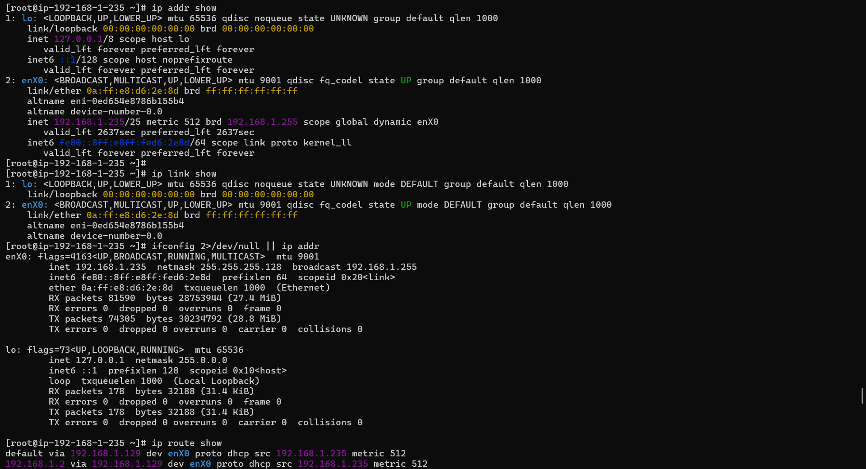
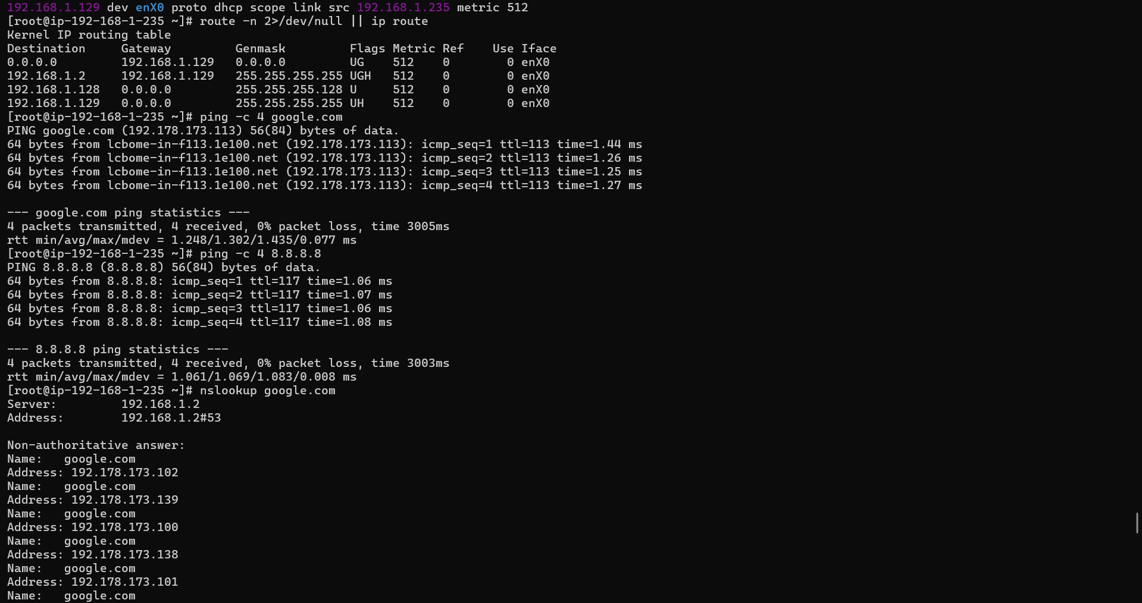
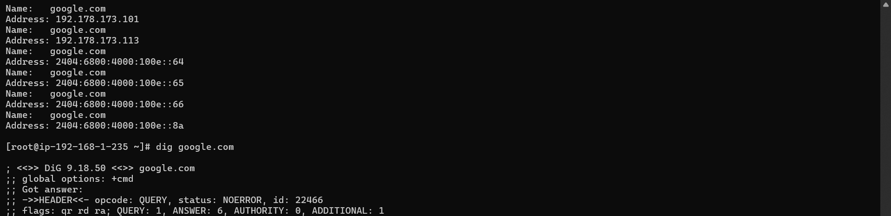
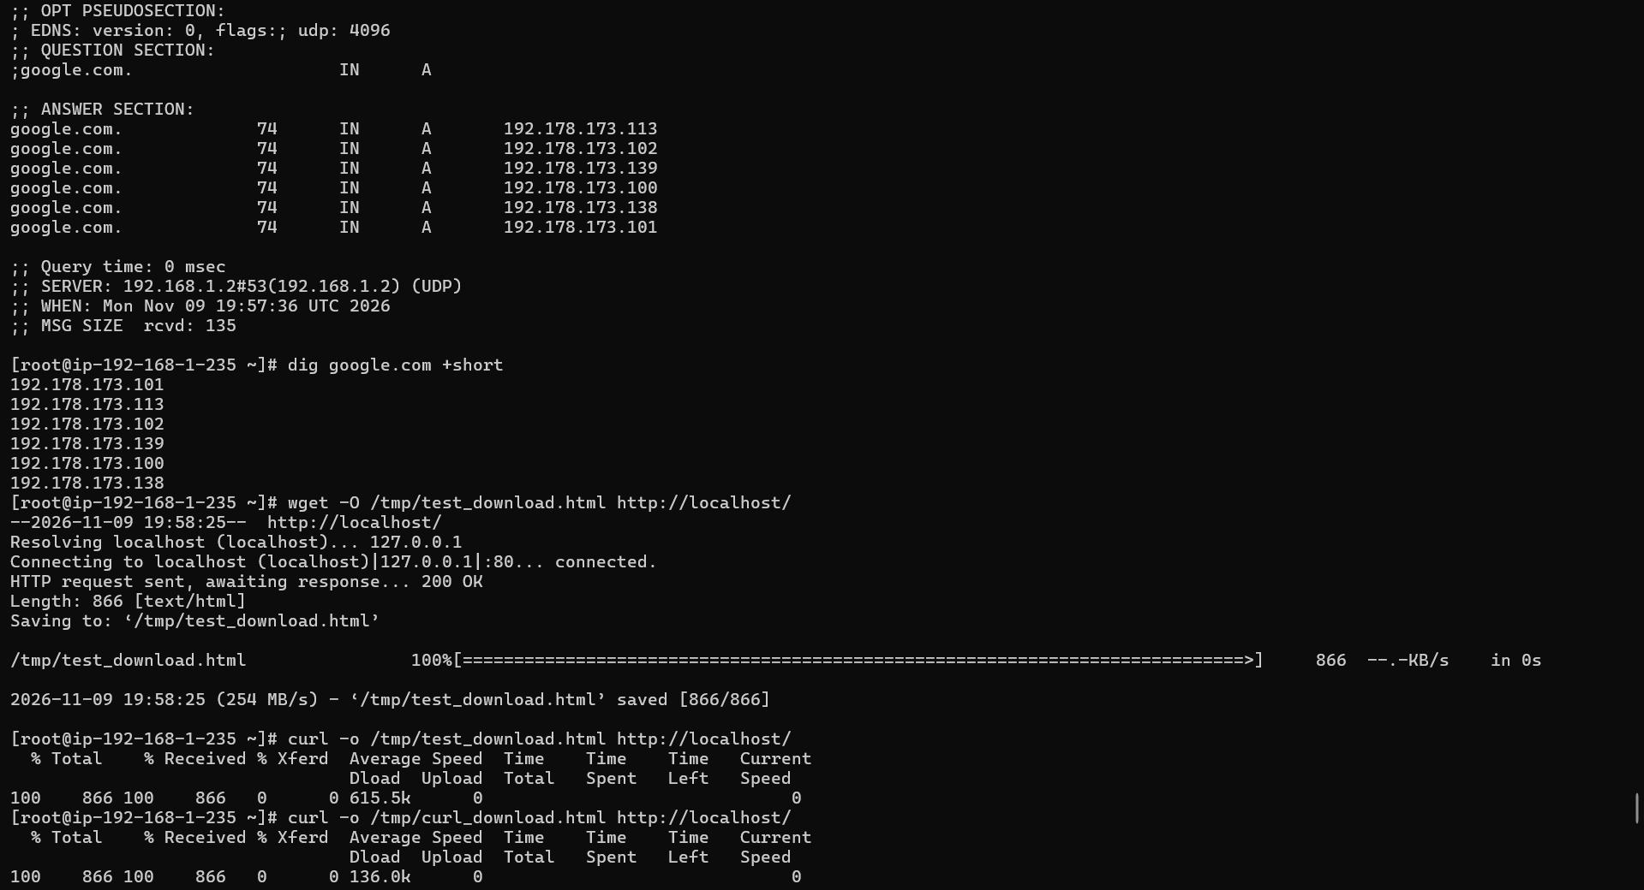
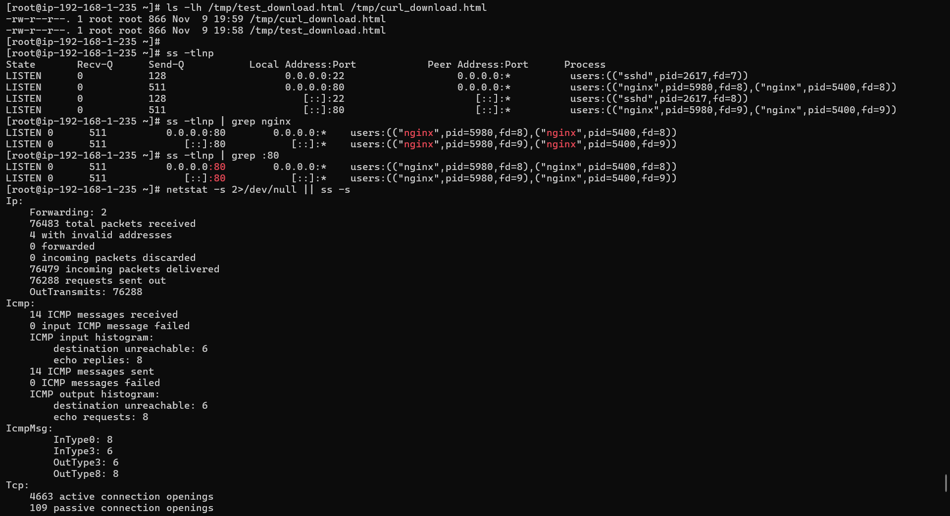
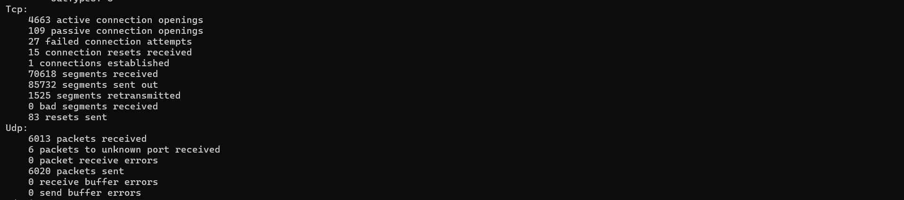
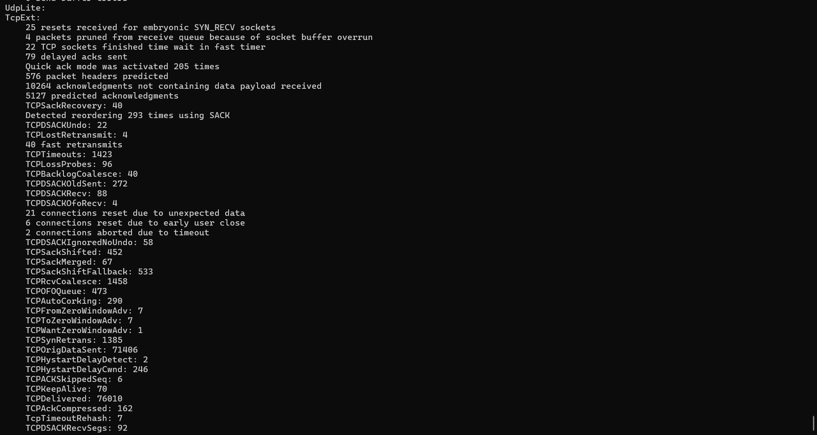
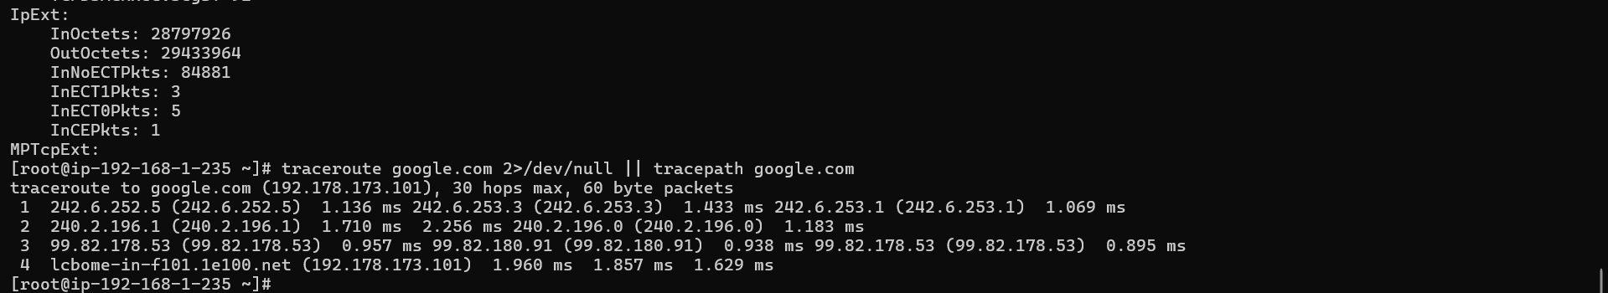

Phase 4 — Shell Scripting & Automation
Step 10: Write a server health check script
Commads:

cat > /usr/local/bin/server_health_check.sh << 'SCRIPT'
#!/bin/bash

# ============================================
# Server Health Check Script
# Linux Capstone Project 2
# ============================================

LOGFILE="/var/log/health_check.log"
TIMESTAMP=$(date '+%Y-%m-%d %H:%M:%S')
PASS=0
FAIL=0

log() {
echo "[$TIMESTAMP] $1" | tee -a $LOGFILE
}

check_service() {
SERVICE=$1
if systemctl is-active --quiet $SERVICE; then
log " PASS: $SERVICE is running"
((PASS++))
else
log " FAIL: $SERVICE is NOT running"
((FAIL++))
# Attempt to restart
systemctl restart $SERVICE
log " Attempted restart of $SERVICE"
fi
}

check_port() {
PORT=$1
NAME=$2
if ss -tlnp | grep -q ":$PORT"; then
log " PASS: Port $PORT ($NAME) is open"
((PASS++))
else
log " FAIL: Port $PORT ($NAME) is NOT open"
((FAIL++))
fi
}

check_disk() {
THRESHOLD=80
USAGE=$(df / | awk 'NR==2 {print $5}' | tr -d '%')
if [ $USAGE -lt $THRESHOLD ]; then
log " PASS: Disk usage is ${USAGE}% (below ${THRESHOLD}% threshold)"
((PASS++))
else
log " WARN: Disk usage is ${USAGE}% (above ${THRESHOLD}% threshold)"
((FAIL++))
fi
}

check_memory() {
FREE_MEM=$(free | awk 'NR==2{printf "%.0f", $4/$2*100}')
if [ $FREE_MEM -gt 10 ]; then
log " PASS: Free memory is ${FREE_MEM}%"
((PASS++))
else
log " WARN: Low memory — only ${FREE_MEM}% free"
((FAIL++))
fi
}

check_http() {
HTTP_CODE=$(curl -s -o /dev/null -w "%{http_code}" http://localhost/)
if [ "$HTTP_CODE" == "200" ]; then
log " PASS: HTTP response code is $HTTP_CODE"
((PASS++))
else
log " FAIL: HTTP response code is $HTTP_CODE (expected 200)"
((FAIL++))
fi
}

# ---- Run All Checks ----
log "========================================"
log "Server Health Check Started"
log "========================================"

check_service "nginx"
check_service "firewalld"
check_port 80 "HTTP"
check_port 22 "SSH"
check_disk
check_memory
check_http

log "========================================"
log "Health Check Complete: PASS=$PASS | FAIL=$FAIL"
log "========================================"
echo ""
SCRIPT

# Make executable
chmod +x /usr/local/bin/server_health_check.sh

# Run the script manually
/usr/local/bin/server_health_check.sh

# View the log output
cat /var/log/health_check.log
Output:
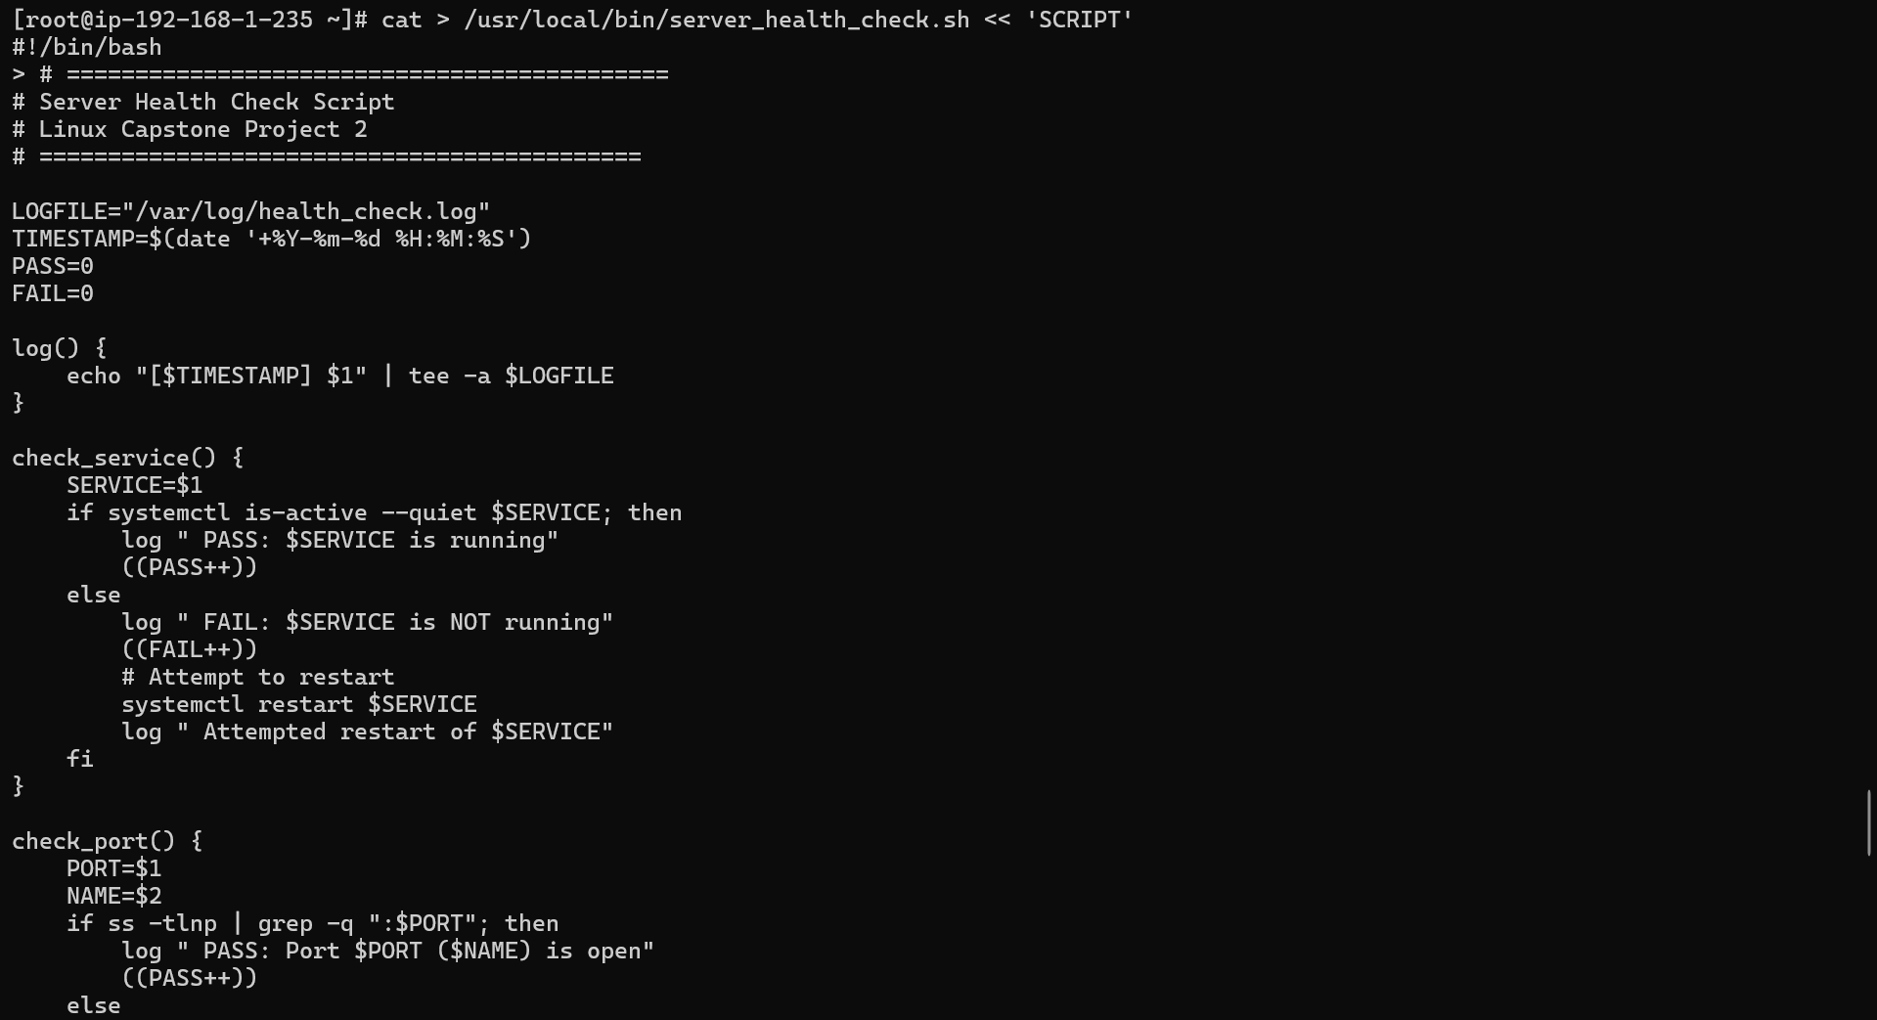
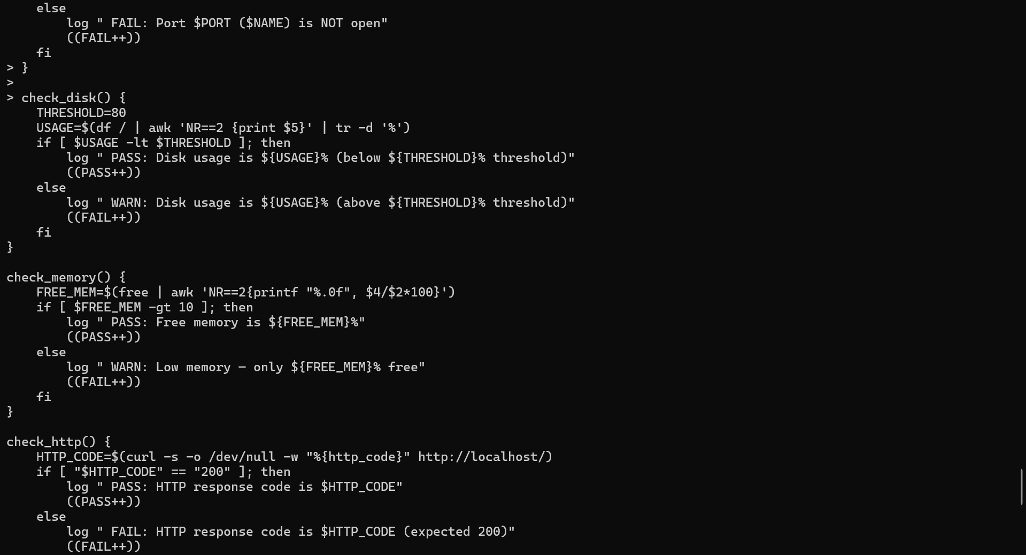
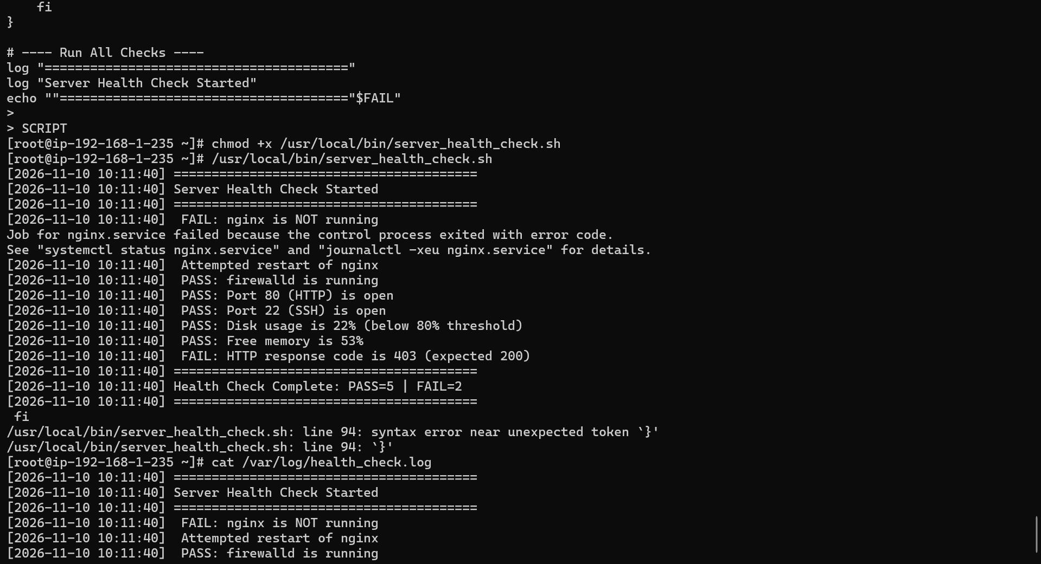
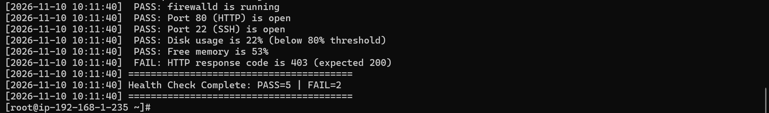
Step 11: Schedule the health check with crontab
Commands:

# Add to crontab — run every 5 minutes
crontab -e
# Add this line:
# */5 * * * * /usr/local/bin/server_health_check.sh

# Verify crontab
crontab -l

# Wait 5 minutes then check if it ran
tail -30 /var/log/health_check.log

Output:
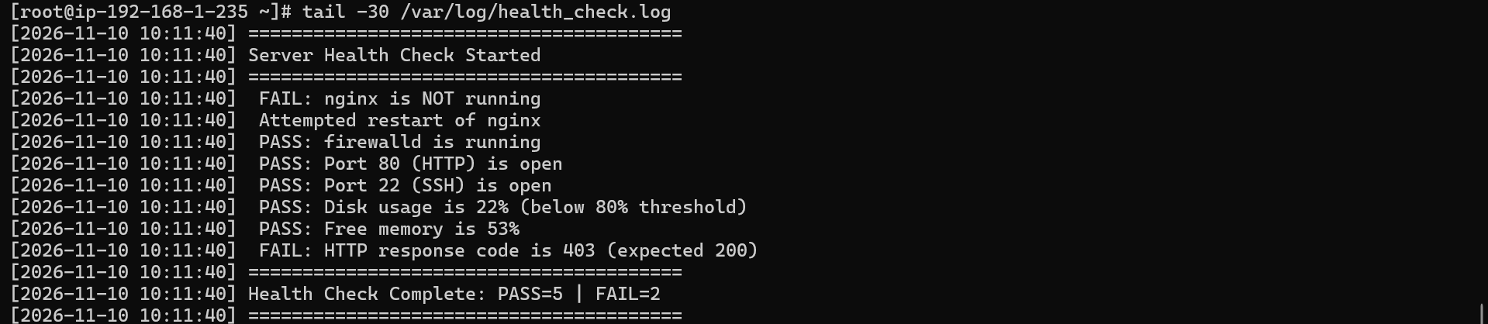

Step 12: Write an if-else script for Nginx management
Commands:

cat > /usr/local/bin/manage_nginx.sh << 'SCRIPT'
#!/bin/bash

# Nginx Service Management Script

ACTION=$1

if [ -z "$ACTION" ]; then
echo "Usage: $0 {start|stop|restart|status}"
exit 1
fi

case $ACTION in
start)
echo "Starting Nginx..."
systemctl start nginx
if systemctl is-active --quiet nginx; then
echo " Nginx started successfully"
else
echo " Failed to start Nginx"
fi
;;
stop)
echo "Stopping Nginx..."
systemctl stop nginx
echo " Nginx stopped"
;;
restart)
echo "Restarting Nginx..."
systemctl restart nginx
if systemctl is-active --quiet nginx; then
echo " Nginx restarted successfully"
else
echo " Failed to restart Nginx"
fi
;;
status)
systemctl status nginx
;;
*)
echo " Invalid action: $ACTION"
echo "Usage: $0 {start|stop|restart|status}"
exit 1
;;
esac
SCRIPT

chmod +x /usr/local/bin/manage_nginx.sh

# Test all options
/usr/local/bin/manage_nginx.sh status
/usr/local/bin/manage_nginx.sh stop
/usr/local/bin/manage_nginx.sh start
/usr/local/bin/manage_nginx.sh restart
/usr/local/bin/manage_nginx.sh invalid

Output:
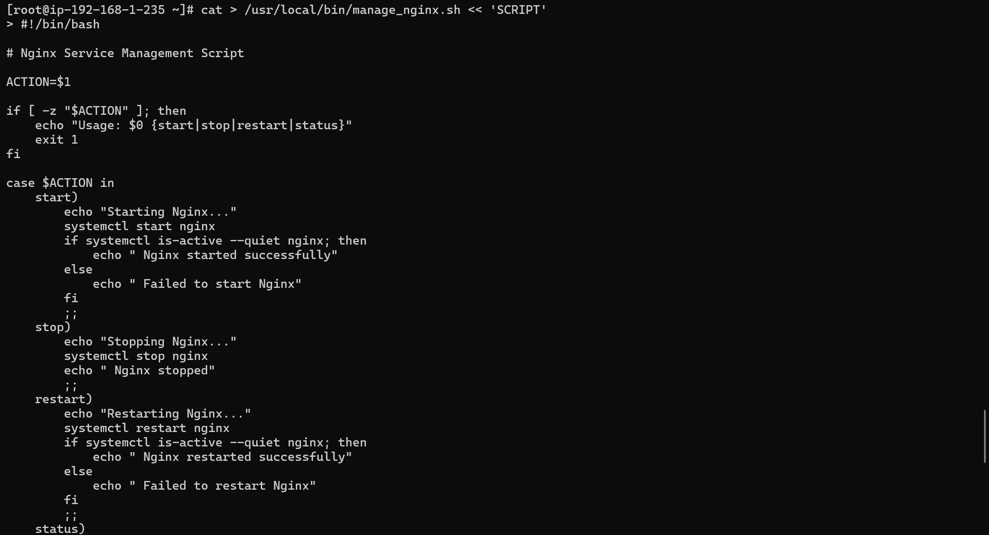
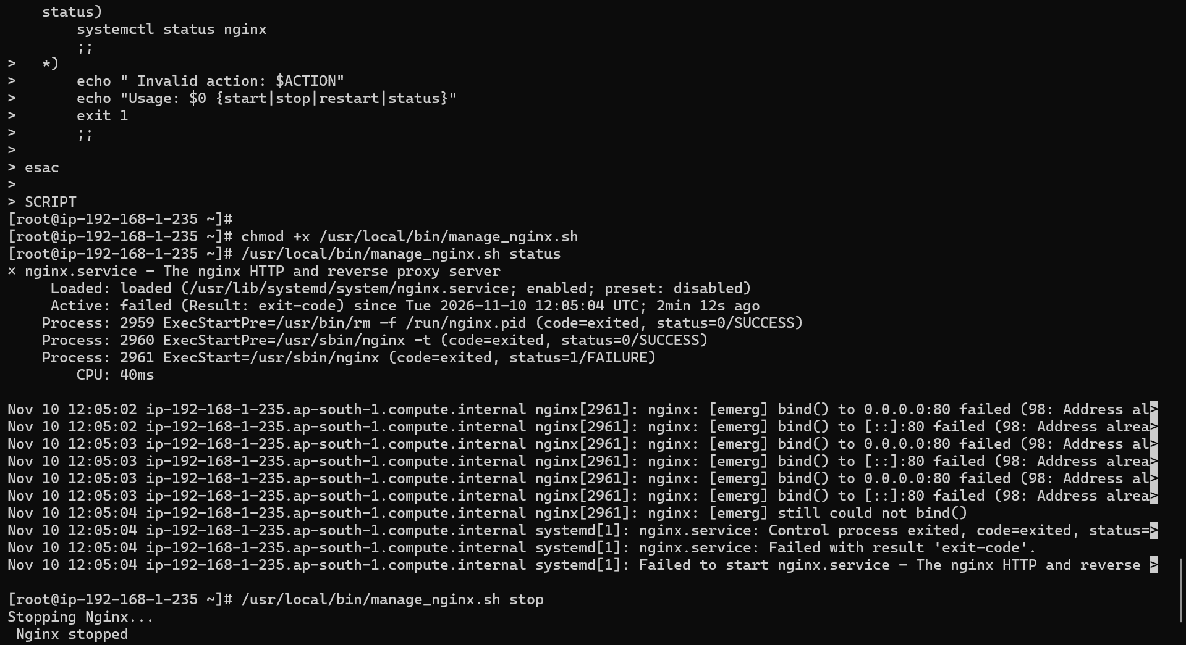
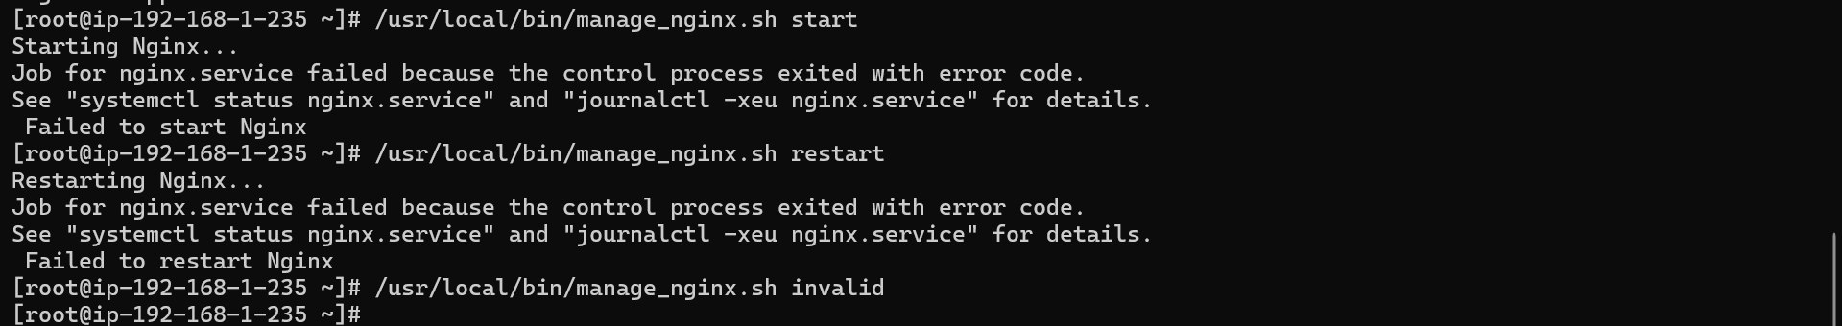

Step 13: Final system state verification
Commands:

# Final check of everything
echo "=== NGINX STATUS ==="
systemctl status nginx --no-pager

echo "=== FIREWALL RULES ==="
firewall-cmd --list-all

echo "=== OPEN PORTS ==="
ss -tlnp

echo "=== DISK USAGE ==="
df -h

echo "=== MEMORY ==="
free -h

echo "=== CRONTAB ==="
crontab -l

echo "=== HEALTH CHECK LOG ==="
tail -20 /var/log/health_check.log

echo "=== NGINX ACCESS LOG ==="
tail -10 /var/log/nginx/access.log

Output:


